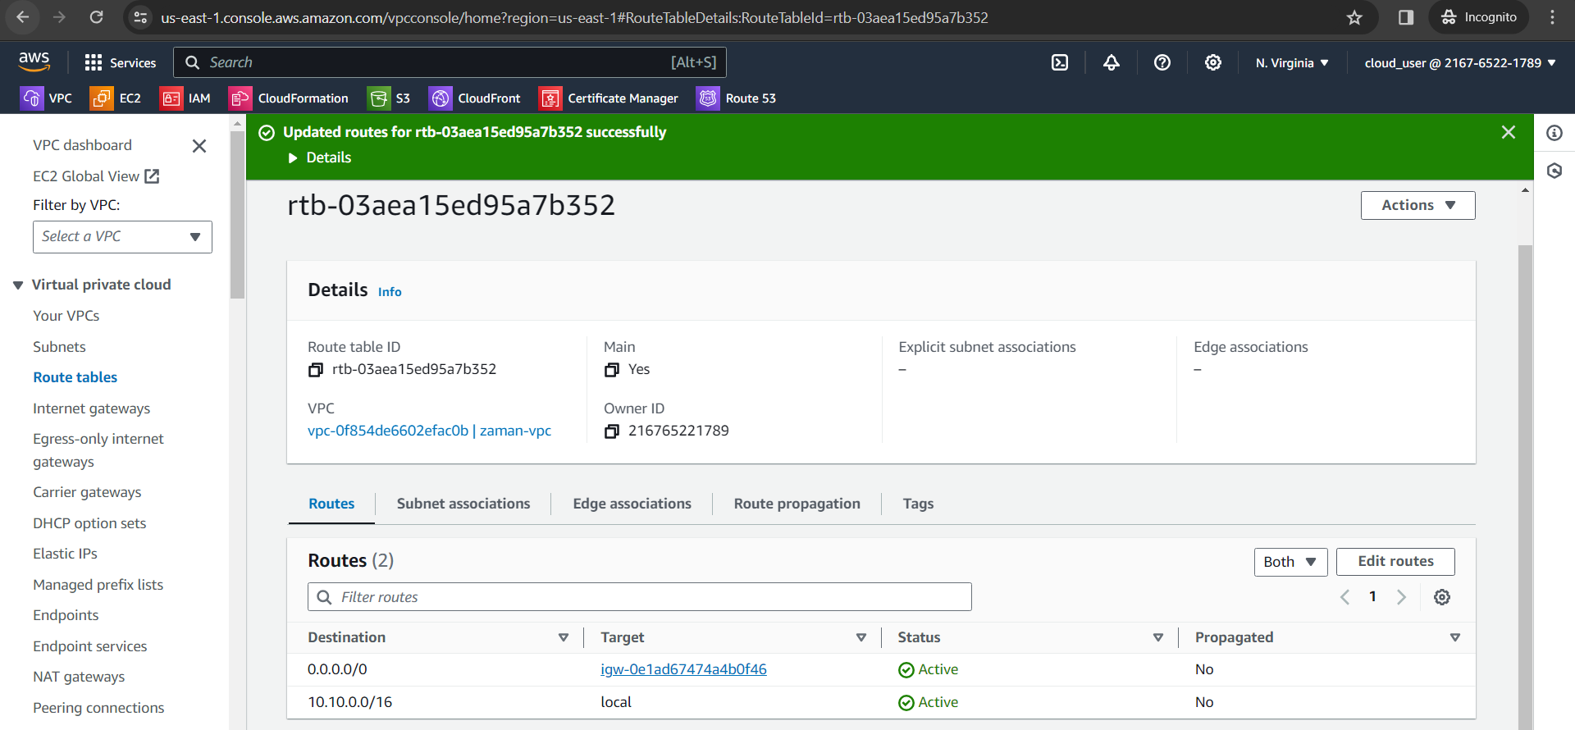

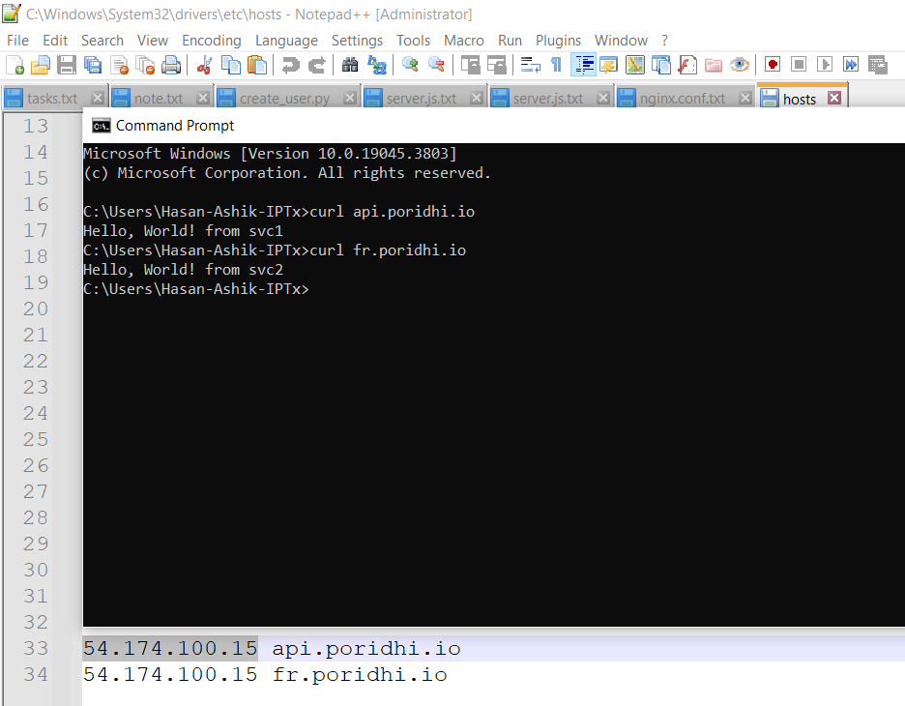

1. Create EC2 instance

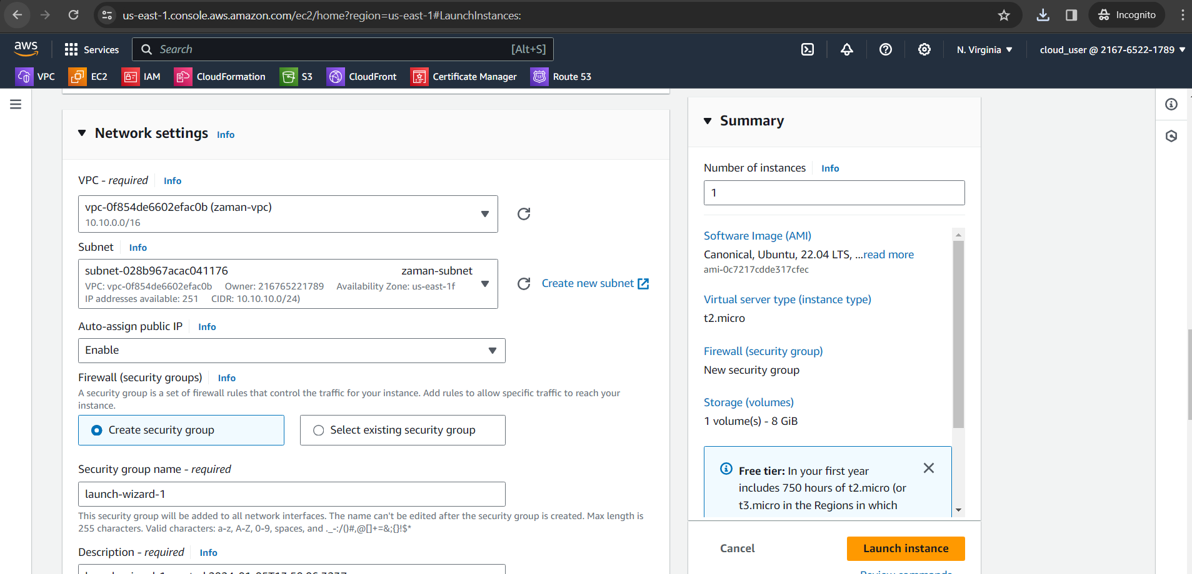

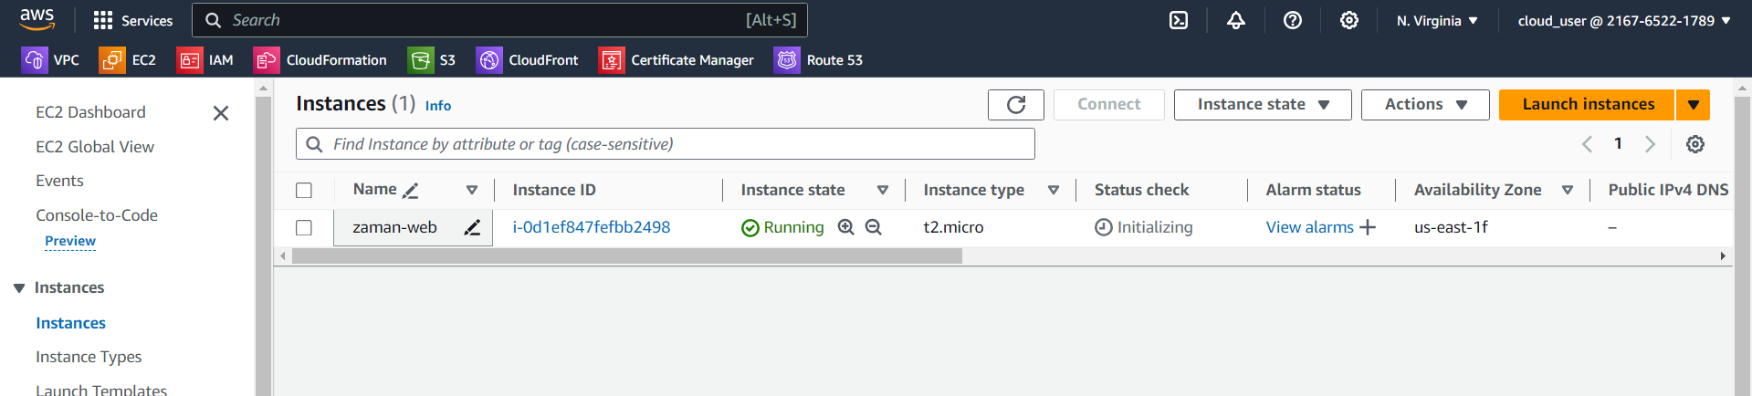

1. Installing Nginx
2. Install Nodejs
3. Create svc1 app

Sudo npm init

npm i express

node server.js

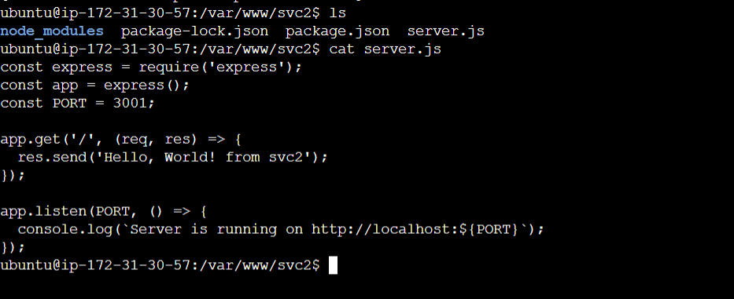

1. Configure Nginx: when request will come from api.poridhi.io and same ip, serve from svc1, and when come from fr.poridhi.io same ip, response from svc2.

nginx -t -c /etc/nginx/nginx.conf

nginx -s reload

Edit host: C:\Windows\System32\drivers\etc

